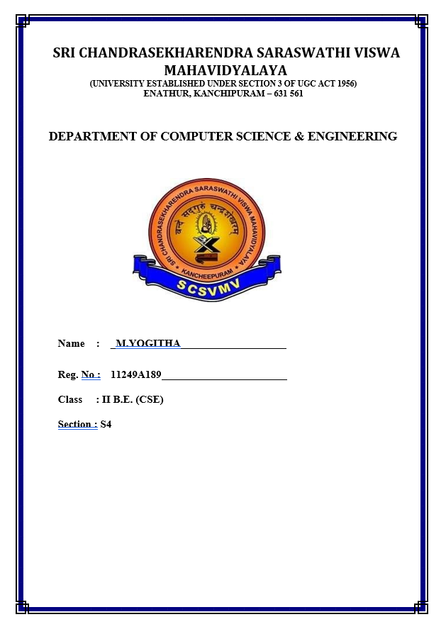

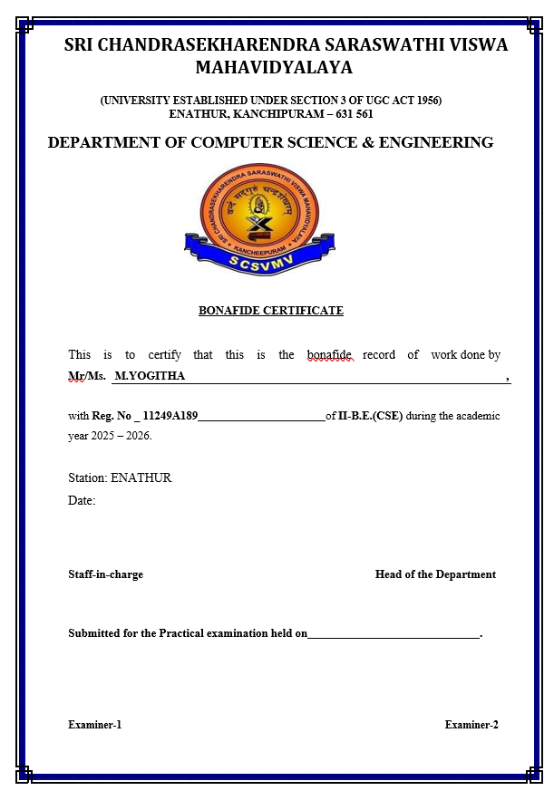

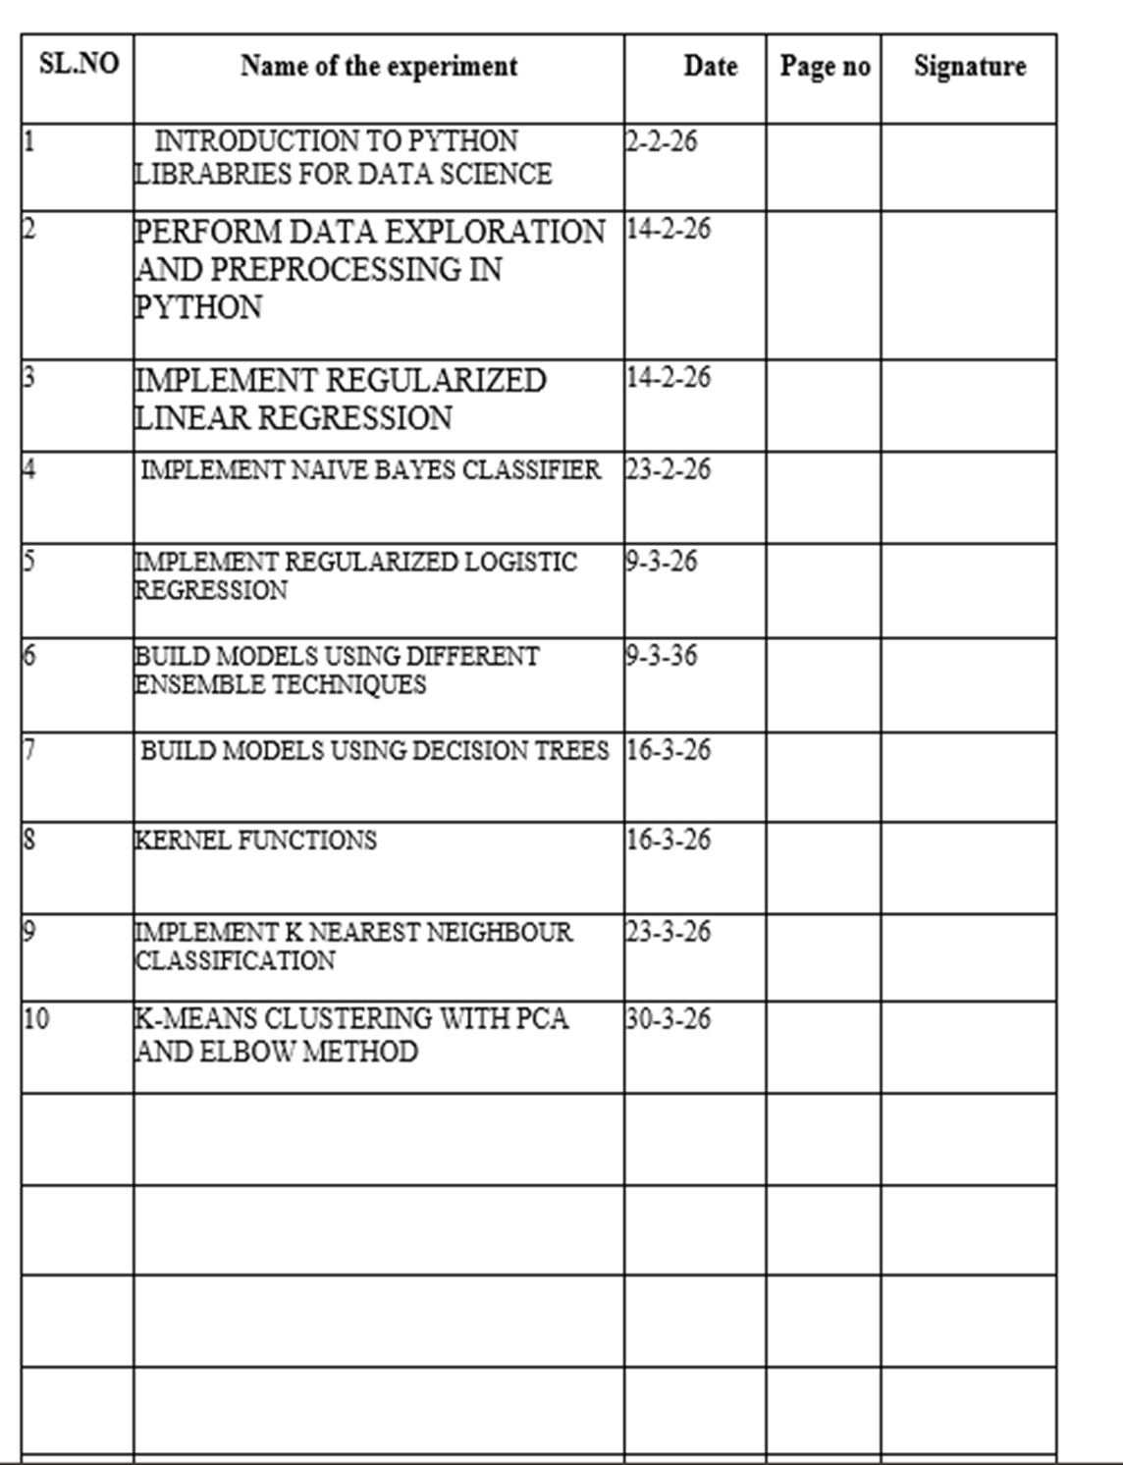

EXP NO:01 INTRODUCTION TO PYTHON LIBRARIES
DATE:02-2-26 FOR DATA SCIENCE

AIM:
To study and understand the basic Python libraries used in data science such as
NumPy, Pandas, Matplotlib, and Scikit-learn.

PROGRAM 1.1:

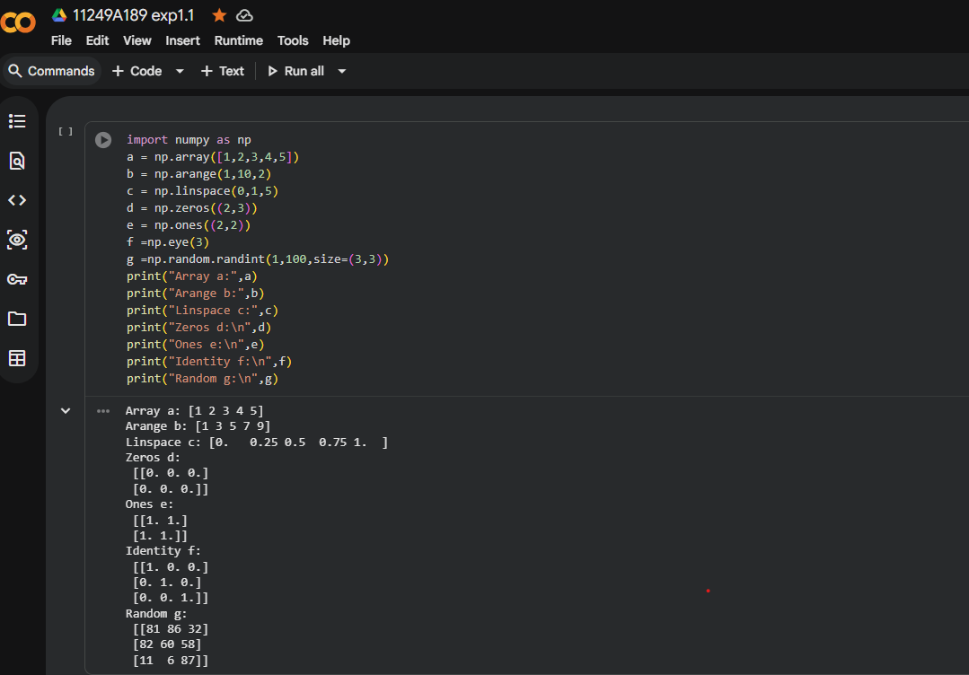

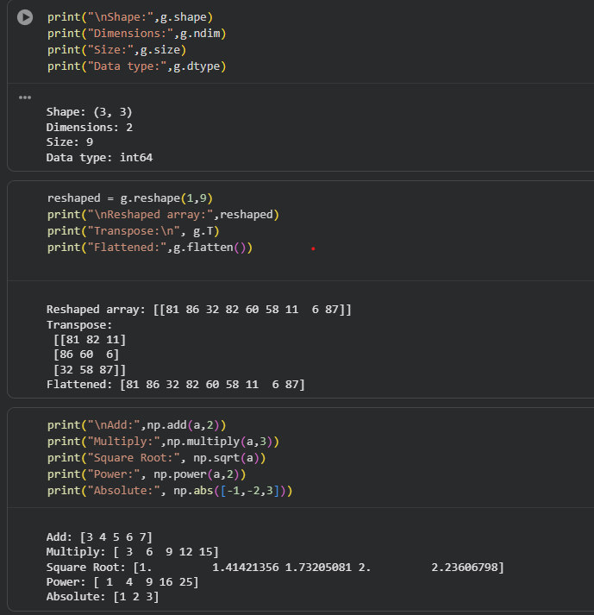

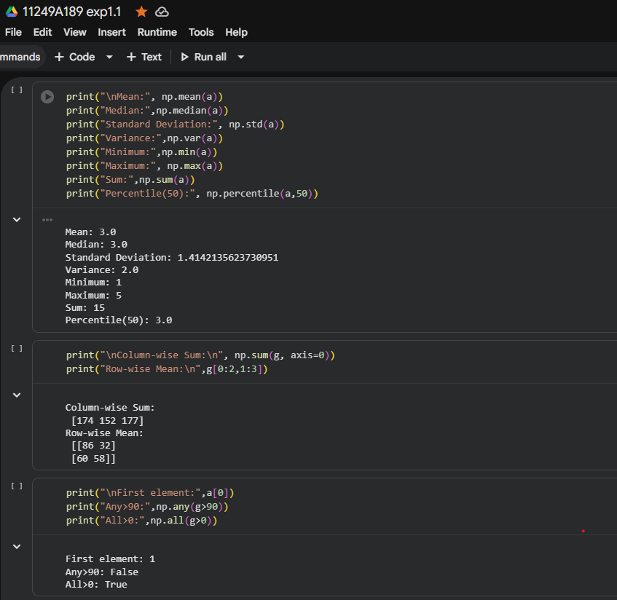
EXP NO:1.2
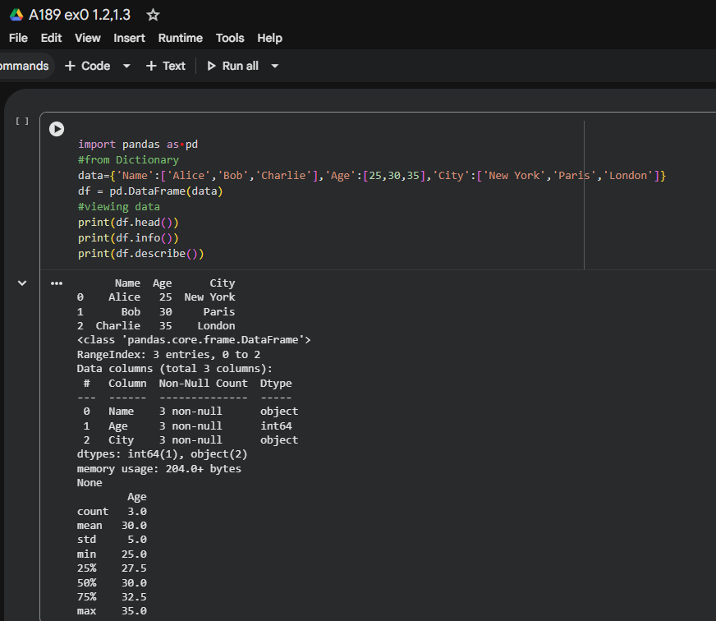
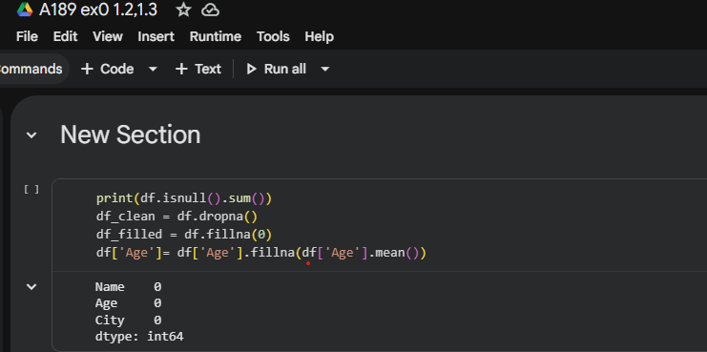

EXP NO:1.3
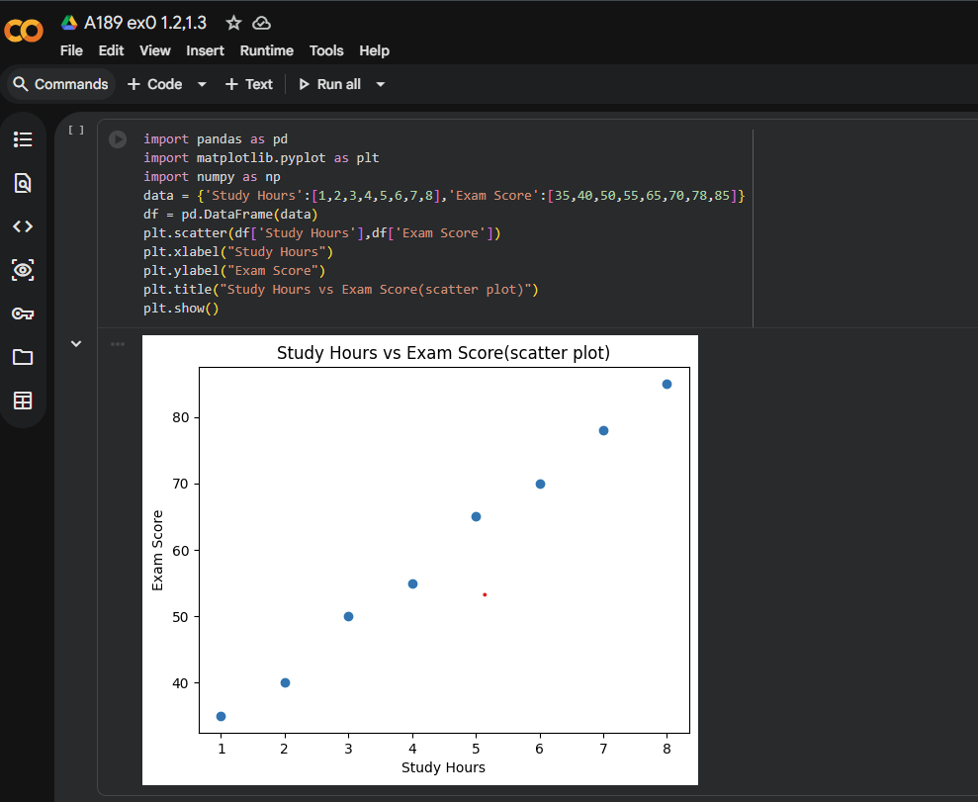
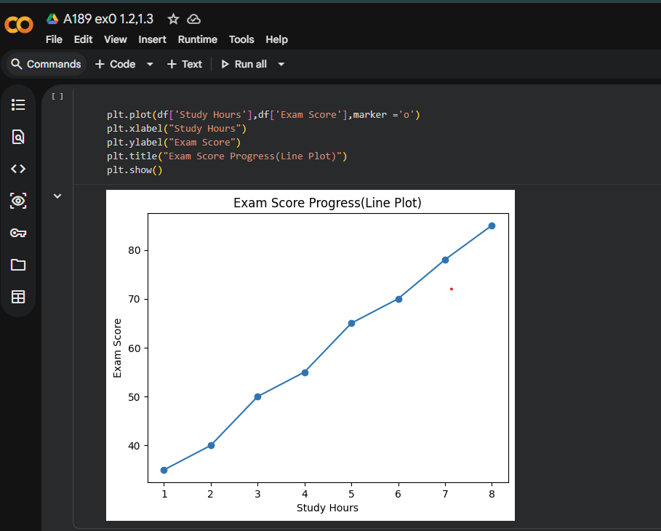
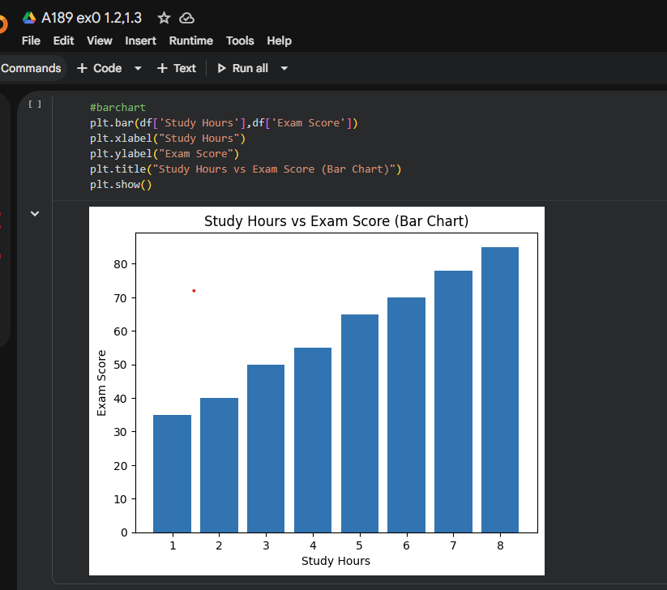
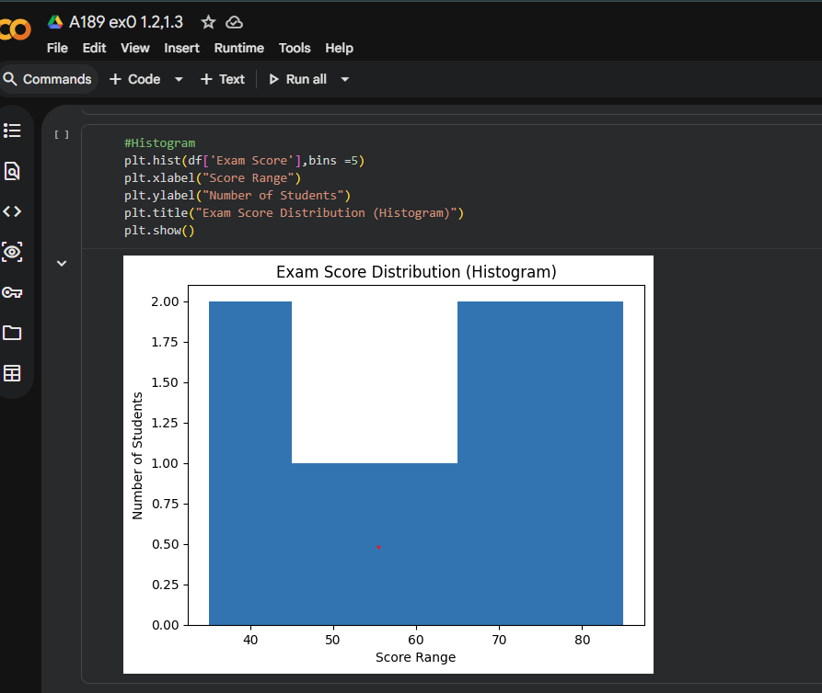

EXP NO:1.4

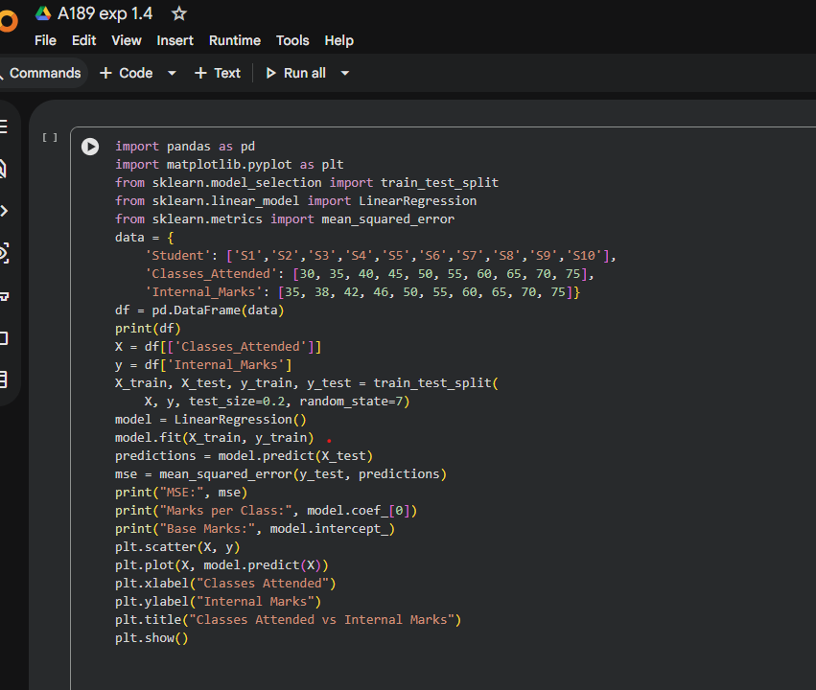

OUTPUT:
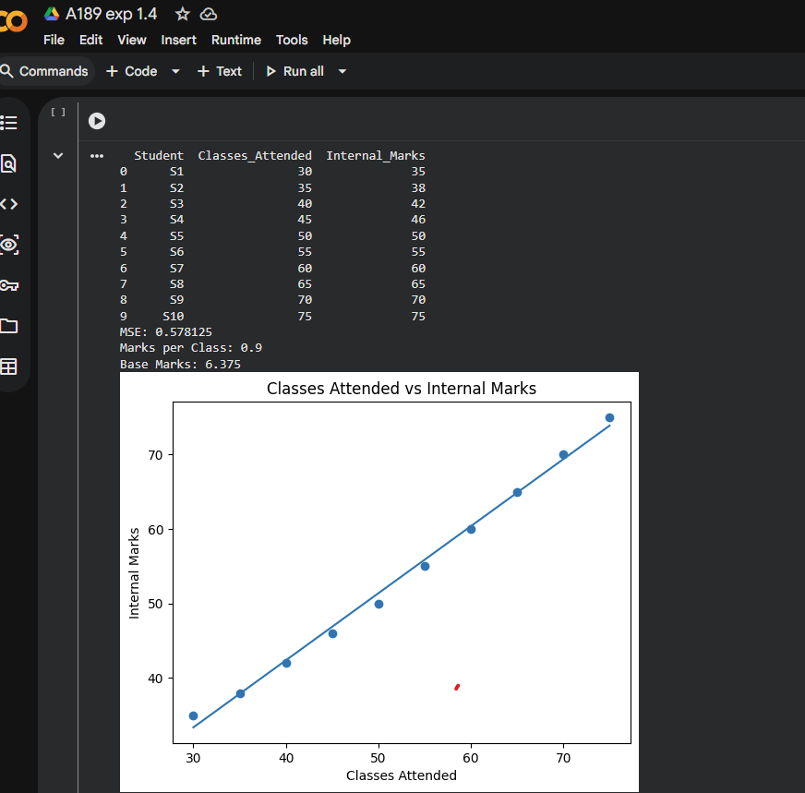

RESULT:
Successfully studied and understood the usage of basic Python libraries such as
NumPy, Pandas, Matplotlib, and Scikit-learn for data science applications.
EXP NO:02 PERFORM DATA EXPLORATION
DATE :14-02-26 PREPROCESSING IN PYTHON

AIM:
To preprocess the dataset by handling missing values, encoding categorical data,
scaling features, and splitting it into training and testing sets for machine learning.
PROGRAM:
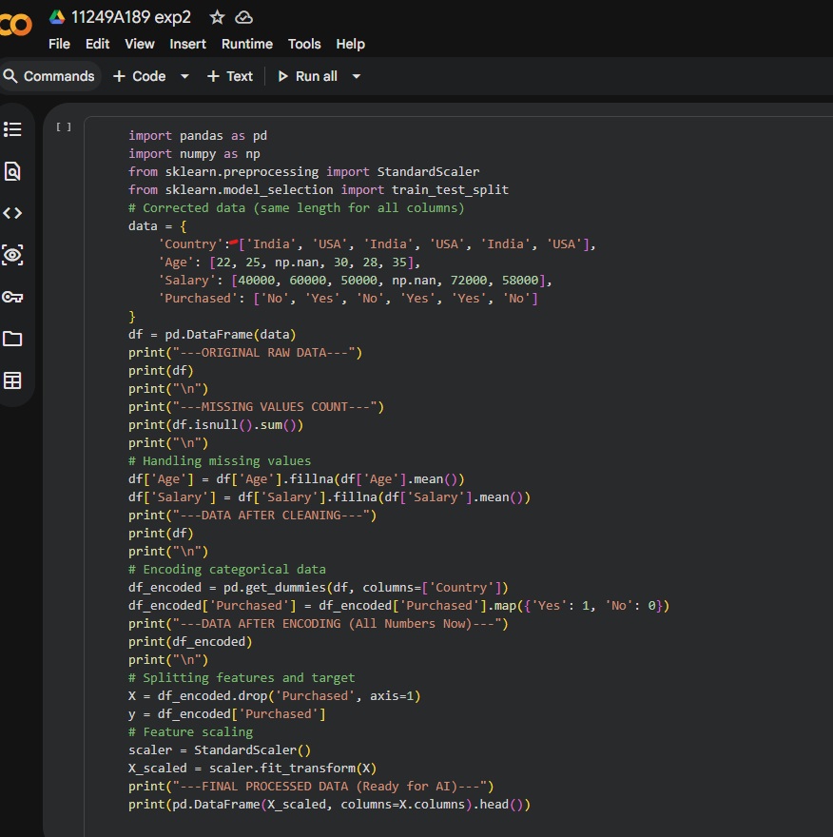
OUTPUT:
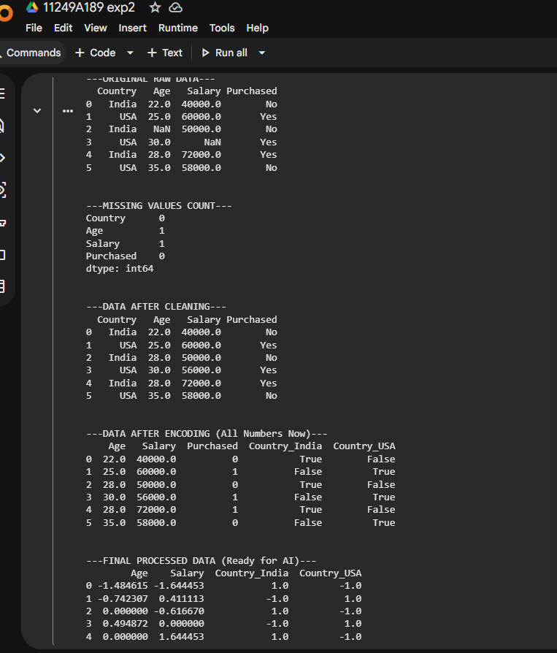
RESULT :
The dataset is successfully pre processed by filling missing values,
Encoding categorical variables,scaling numerical features,and splitting it into training and splitting it into training and testing sets ready for machine learning.

EXP:03 IMPLEMENT REGULARIZED LINEAR REGRESSION
DATE:14-02-26

AIM:
To implement and compare Linear Regression, Ridge Regression, and Lasso Regression models using a dataset, and evaluate their performance by calculating the Mean Squared Error (MSE).
PROGRAM:
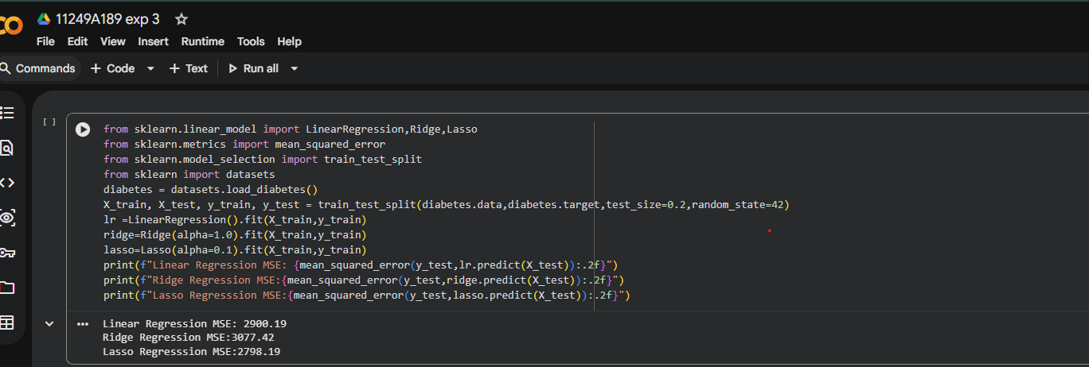
RESULT:
Lasso Regression gave the lowest MSE,so it performed best among the three models.

EXP NO: 04 IMPLEMENT NAÏVE BAYES
DATE:23-02-26 CLASSIFIER

Aim:
To implement a Naïve Bayes Classifier using the scikit-learn library in Python to classify data based on given features and to evaluate the model performance using accuracy.
PROGRAM:
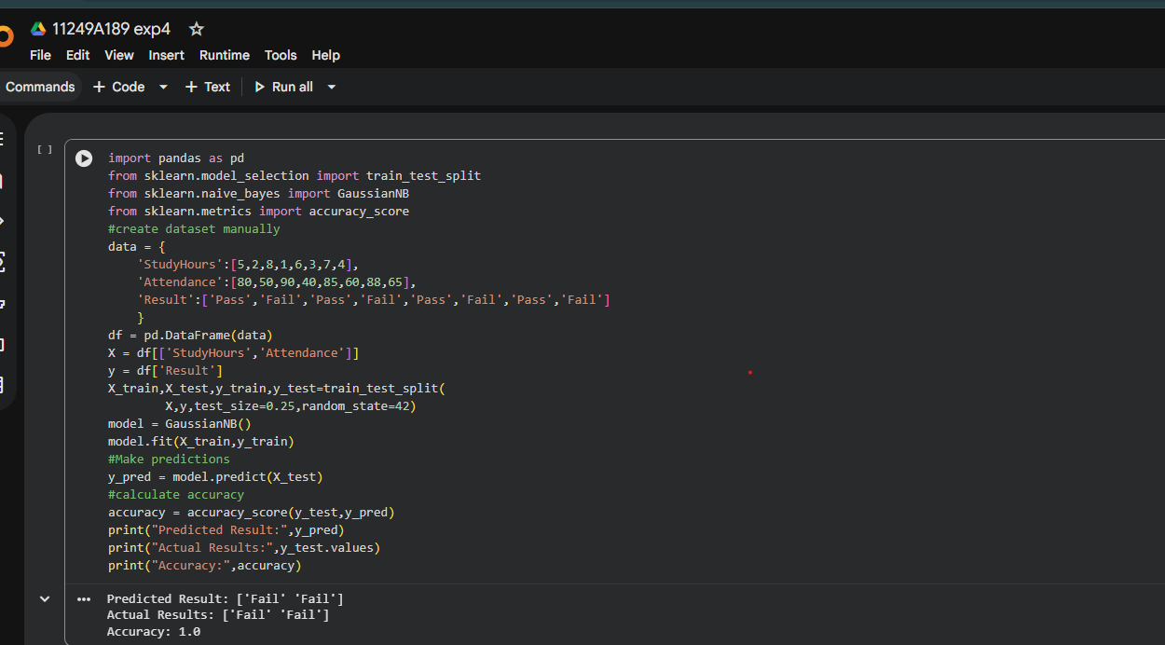
RESULT:
The Naïve Bayes Classifier was successfully implemented using scikit-
learn, and the model correctly classified the test data with an accuracy of
- (100%).

EXP NO:05 IMPLEMENT REGULARIZED
DATE: 09-03-26 LOGISTIC REGRESSION
AIM:To implement Logistic Regression and Regularized Logistic Regression
on a dataset using scikit-learn, and to compare their performance based
on accuracy.
PROGRAM:
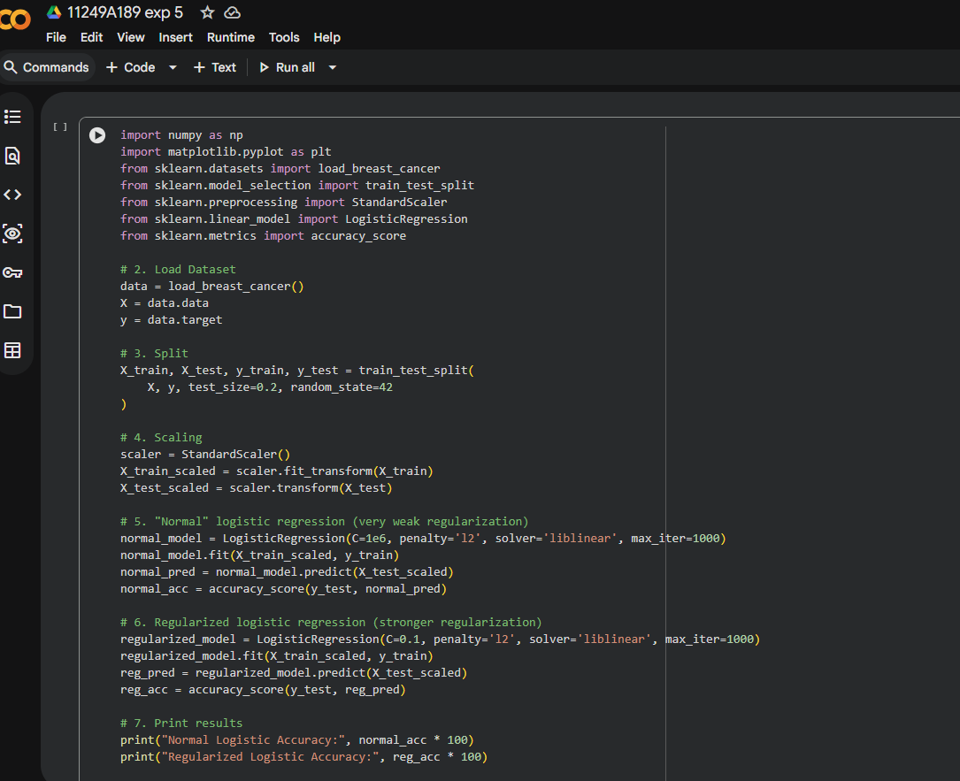
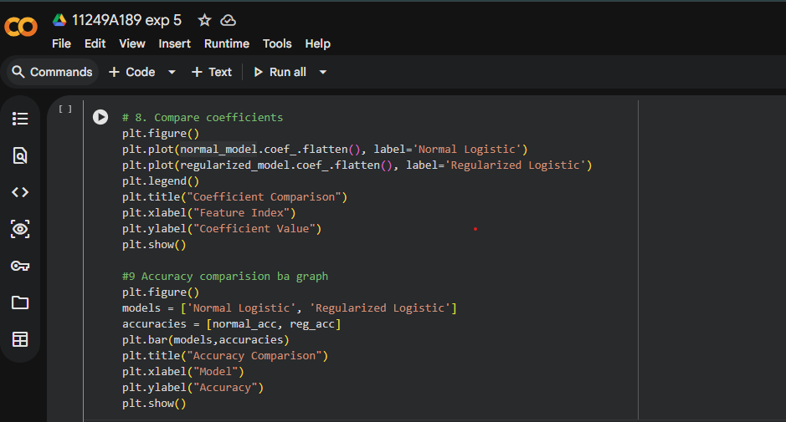
OUTPUT:
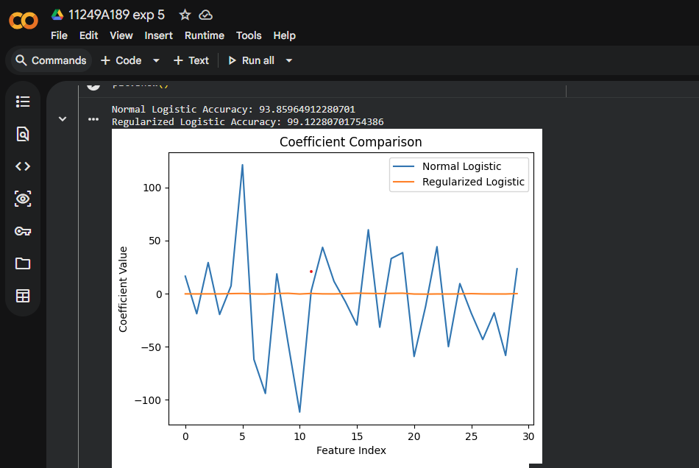
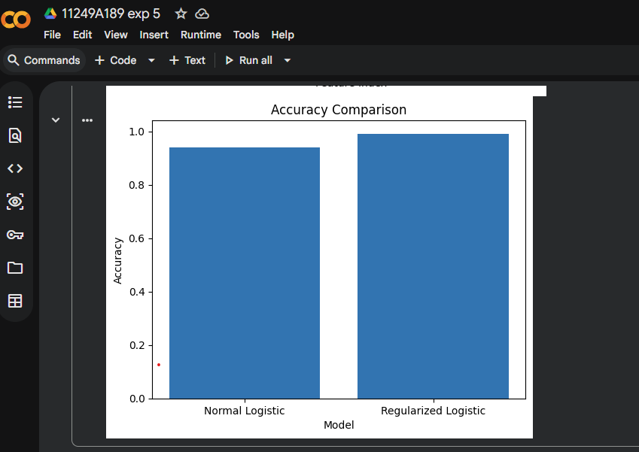

RESULT:
The Logistic Regression models were executed successfully, and the regularizedmodel showed slightly higher accuracy (~94–96%) compared to the normal model (~93.85%).
EXP NO: 06 BUILD MODELS USING DIFFERENT
DATE: 9-03-26 ENSEMBLING TECHNIQUES

AIM:
To implement and compare different Ensemble Learning methods—specifically
Random Forest (Bagging), AdaBoost (Boosting), and Stacking—to evaluate how
combining multiple models improves classification accuracy on the Iris dataset
PROGRAM:
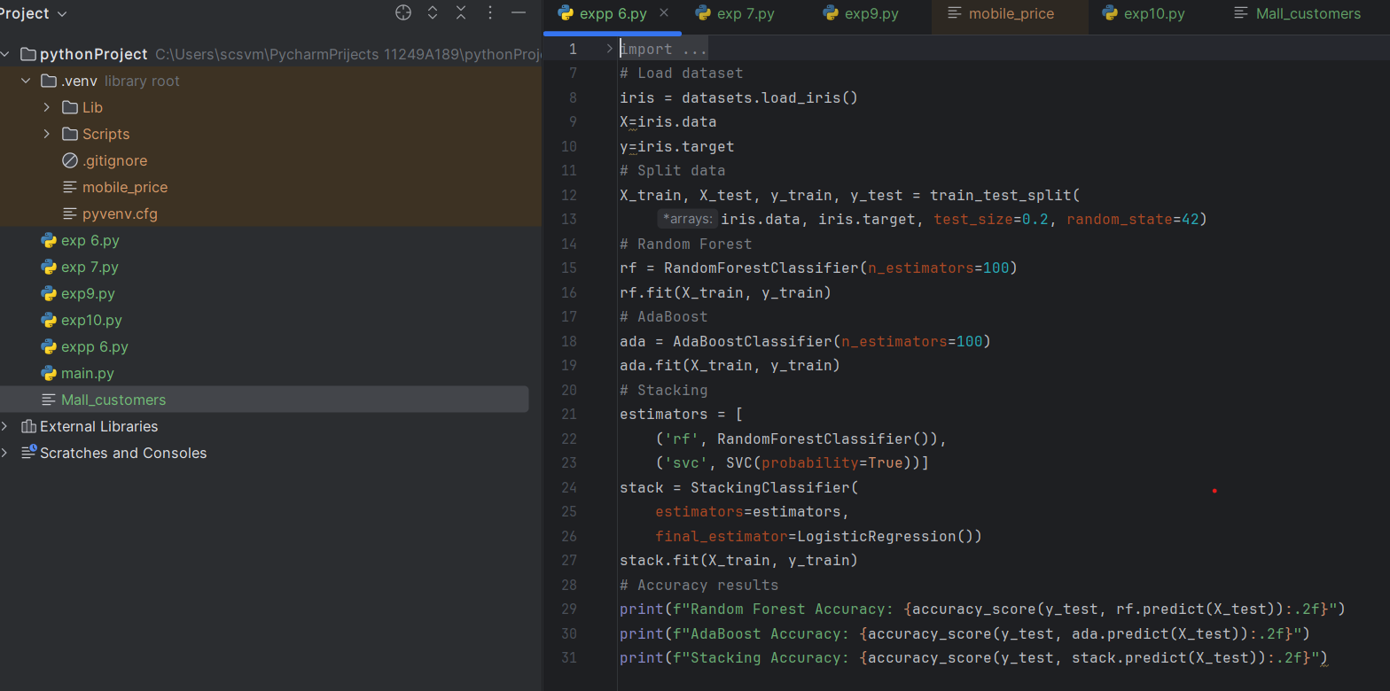

OUTPUT:
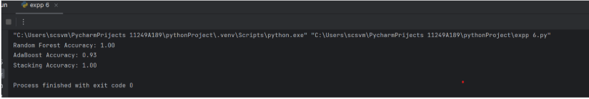

RESULT :
The experiment successfully implemented Random Forest, AdaBoost, and Stackingon the Iris dataset. It was observed that ensemble methods improved classificationaccuracy by reducing error and variance.

EXP NO: 07 BUILD MODELS USING DECISION TREE
DATE: 16-03-26
AIM:
To implement a Decision Tree Classification model using Scikit-learn to classify Iris flower species and evaluate the model &#39;s performance through accuracy metrics and feature importance analysis
PROGRAM:
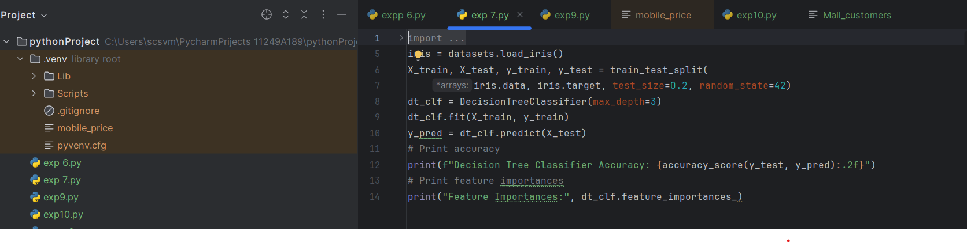
OUTPUT:
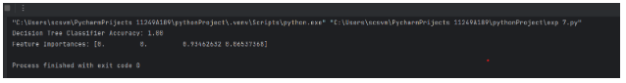

RESULT:
The Decision Tree model successfully classified the Iris species with high accuracy using a maximum depth of 3. The output confirmed that the model effectively identified key feature importances, showing which physical traits most influence the classification.

EXP NO:08 KERNEL FUNCTIONS
DATE:16-03-26

AIM:
To implement and compare the performance of a Support Vector Machine (SVM) classification model using different kernel functions (Linear, Polynomial, and Radial Basis Function (RBF)) on the Iris dataset to evaluate their predictive accuracy.
PROGRAM: 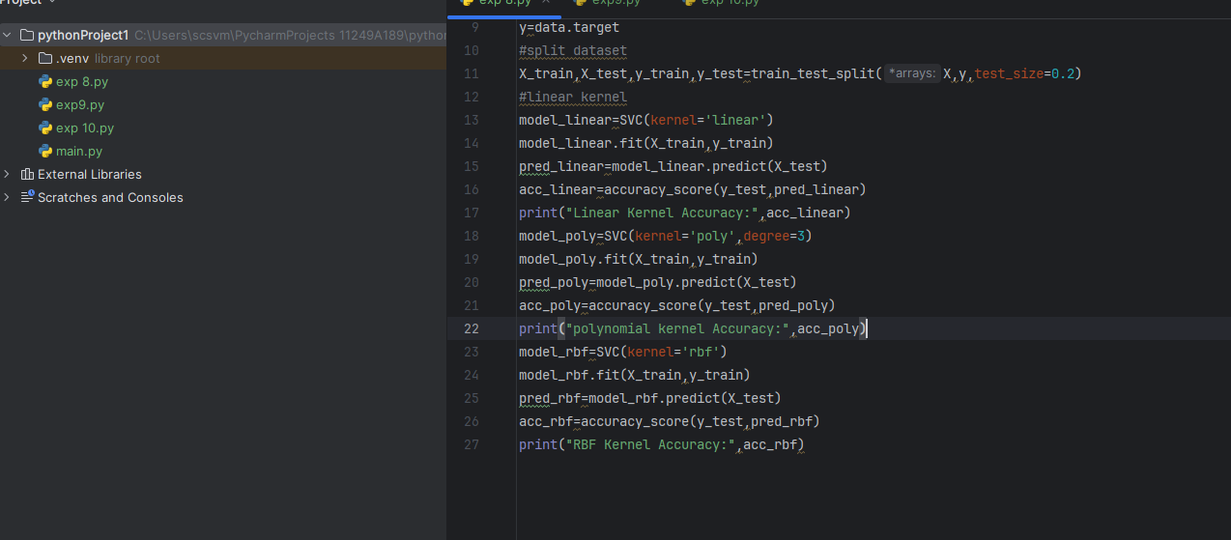
OUTPUT:
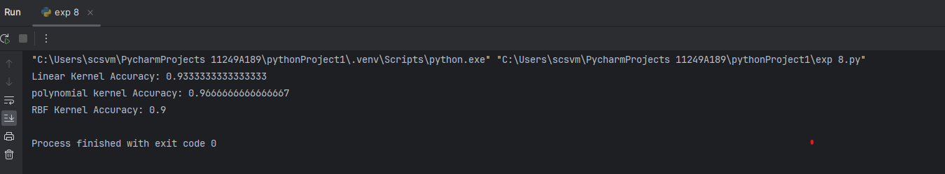

RESULT:
The SVM model was successfully implemented, demonstrating that Linear and RBF kernels generally yield the highest classification accuracy on the Iris dataset
EXP NO:09 IMPLEMENT K-NEAREST NEIGHBORS
DATE:23-03-26 CLASSIFICATION

AIM:
To build and evaluate a classification model using K-Nearest Neighbours on mobile price data by splitting the dataset, scaling features, and measuring performance using accuracy and classification metrics.

PROGRAM:
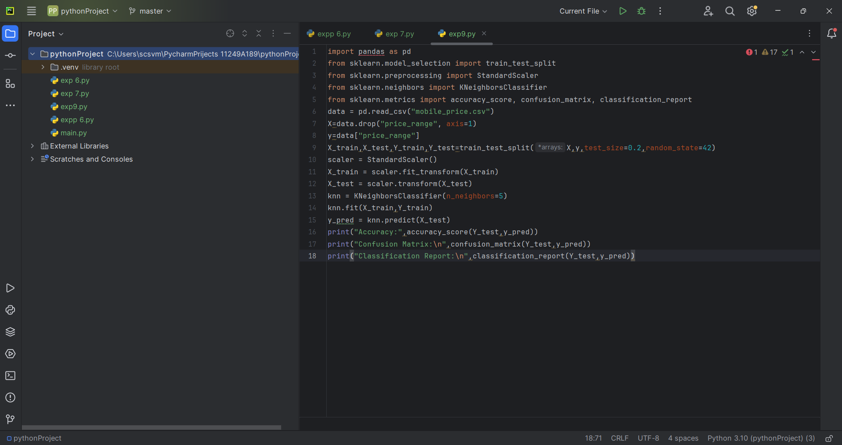

OUTPUT:

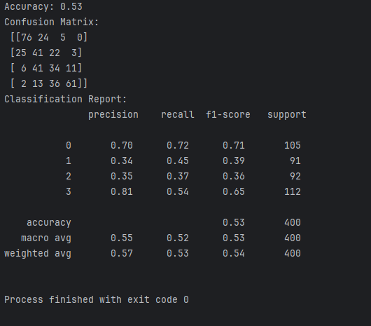

RESULT:
The K-Nearest Neighbours model is successfully trained and tested on the mobile price dataset, achieving classification results with calculated accuracy, confusion matrix, and classification report, indicating how well the model predicts price ranges.

EXP NO: 10 K-MEANS CLUSTERING WITH PCA
DATE: 30-03-26 AND ELBOW METHOD

AIM:
To perform dimensionality reduction using PCA and apply K-Means clustering to identify patterns in the dataset, using the elbow method to determine the optimal number of clusters and visualizing the results.
PROGRAM:
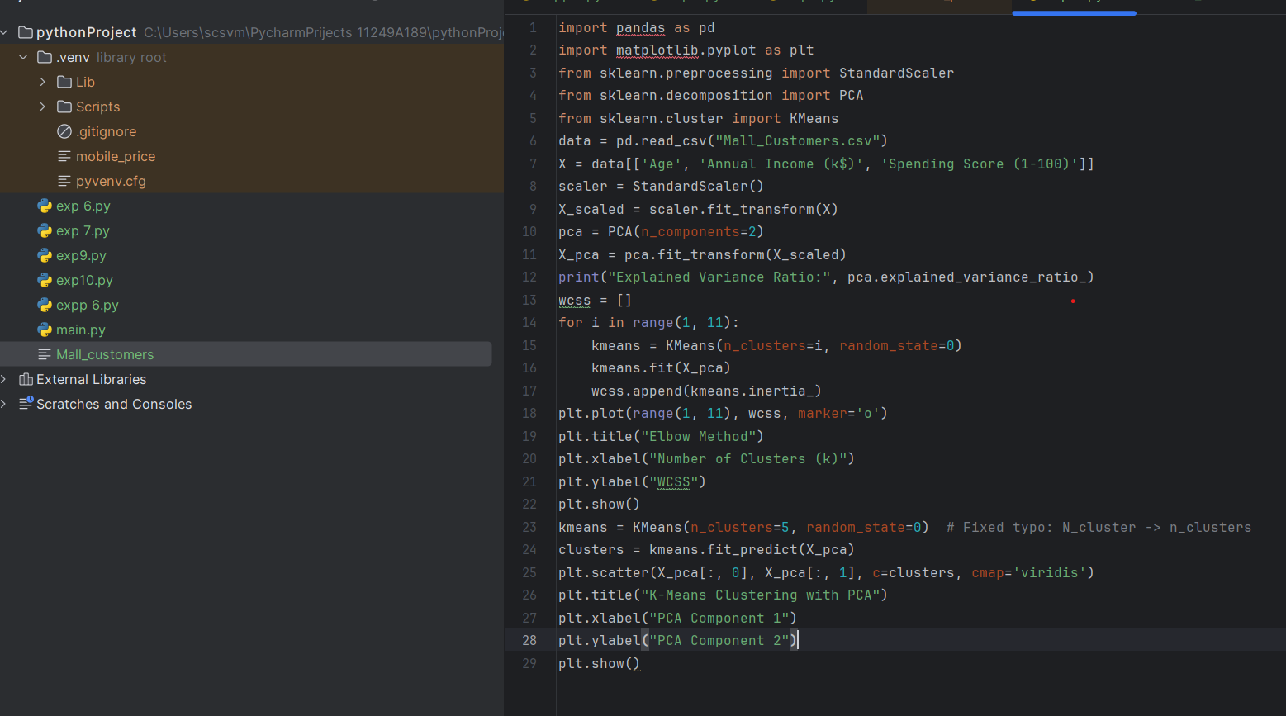

OUTPUT:
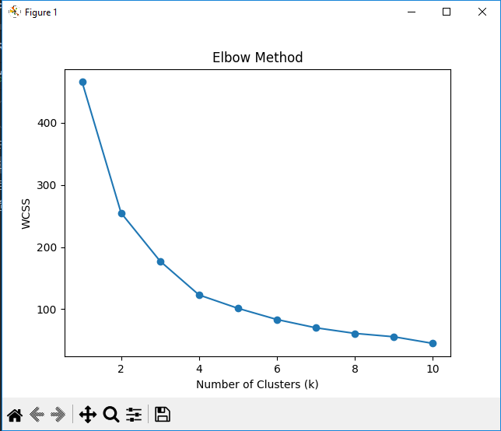
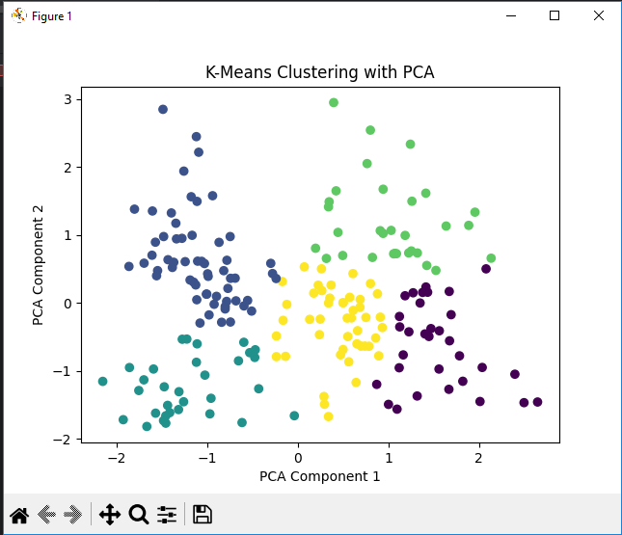

RESULT:
Data is reduced using PCA, optimal clusters are found, and K-Means successfully groups the data into clear clusters.

